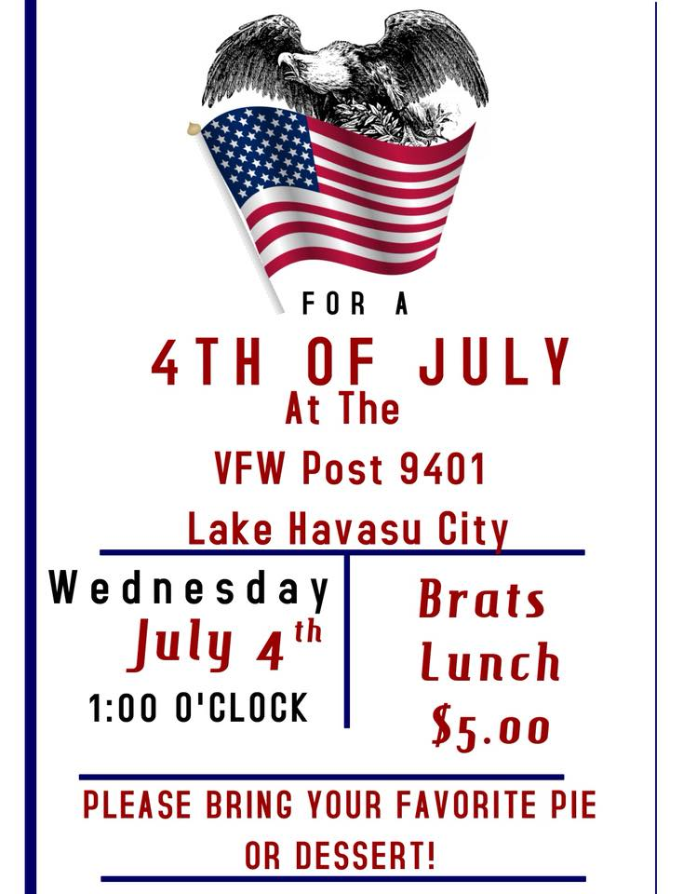
ALL VETERANS AND FAMILIES WELCOME!
CELEBRATE INDEPENDENCE DAY WITH YOUR COMRADES
QUESTIONS? CALL 928-855-5374 OR 928-230-4931

