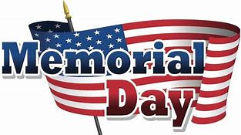

MEMORIAL DAY CEREMONY

Lake Havasu Memorial Gardens
1698 Deer Run Drive
Monday, May 28, 2018
10:00 a.m.

Guest Speaker: Lake Havasu City Mayor Mark Nexsen

*Please bring a chair.

Sponsored by VFW Post 9401: 928-855-5374

