TABE TESTING BY APPOINTMENT ONLY. See your Career Coach or Staff member in the job center if you need an appointment.
Bullhead City June 2018
One-Stop Workshop Calendar
Hours of operation: Monday – Friday from 8:00am to 5:00pm
Our #1 Job Is Helping You Find a Job

Monday | Tuesday | Wednesday | Thursday | Friday
28 | 29 | 30 | 31 | 1
TABE Testing by Appointment only | Orientation  9:00AM
4 | 5 | 6 | 7 | 8
Orientation  9:00AM |  | Job Skills Match 1:30pm  Career Exploration 2:00pm  Resume Building 2:30pm | Interviewing with Confidence 1pm  What Employers Want  Job Applications 1:30pm | 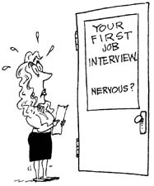
11 | 12 | 13 | 14 | 15
TABE Testing by Appointment only | Orientation  9:00AM
18 | 19 | 20 | 21 | 22
Orientation  9:00AM |  | Job Skills Match 1:30pm  Career Exploration 2:00pm  Resume Building 2:30pm | Interviewing with Confidence 1pm  What Employers Want  Job Applications 1:30pm
25 | 26 | 27 | 28 | 29
TABE Testing by Appointment only | Orientation  9:00AM
Helpful Websites:
https://www.arizonaatwork.com/
https://www.azjobconnection.gov/ada/r

For more information; 2601 S Hwy 95, Bullhead City (928-758-0702) TTY 711

