TABE TESTING BY APPOINTMENT ONLY. See your Career Coach or Staff member in the job center if you need an appointment.
Lake Havasu July 2018
One-Stop Workshop Calendar
Hours of operation: Monday – Friday from 8:00am to 5:00pm
Job center is closed for lunch from
Noon-1pm
Our #1 Job Is Helping You Find a Job

Monday | Tuesday | Wednesday | Thursday | Friday
02 | 03  TABE Testing by Appointment only | 04  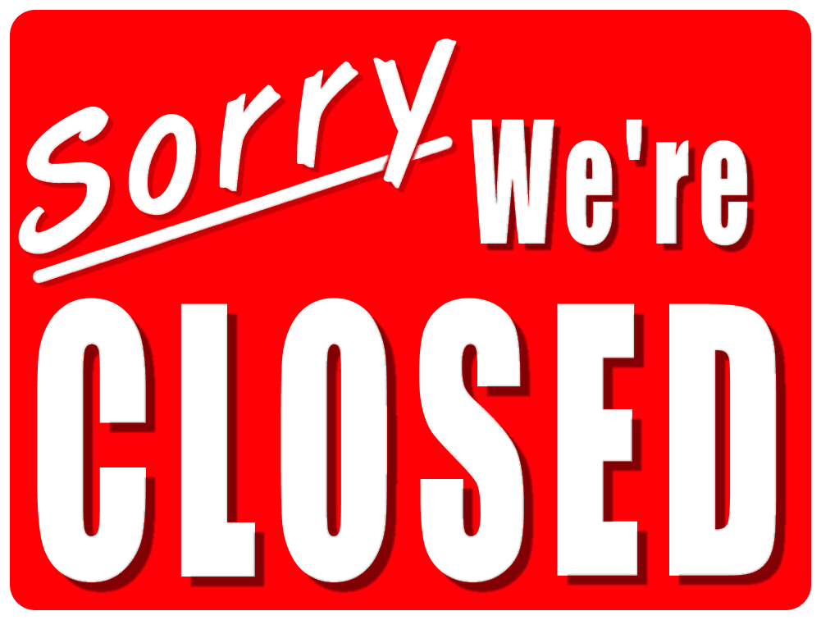 | 05 | 06
09 | 10 | 11 | 12 | 13
 | TABE Testing by Appointment only | Orientation 9:00-11AM | Job Skills Match 2pm  Career Exploration 2:30pm  Resume Building 3pm | Interviewing with Confidence 2:00pm  What Employers Want 2:30pm  Job Applications  3:00pm
16 | 17 | 18 | 19 | 20
 | TABE Testing by Appointment only | Orientation 9:00-11AM | Job Skills Match 2pm  Career Exploration 2:30pm  Resume Building 3pm | Interviewing with Confidence 2:00pm  What Employers Want 2:30pm  Job Applications  3:00pm
23 | 24 | 25 | 26 | 27
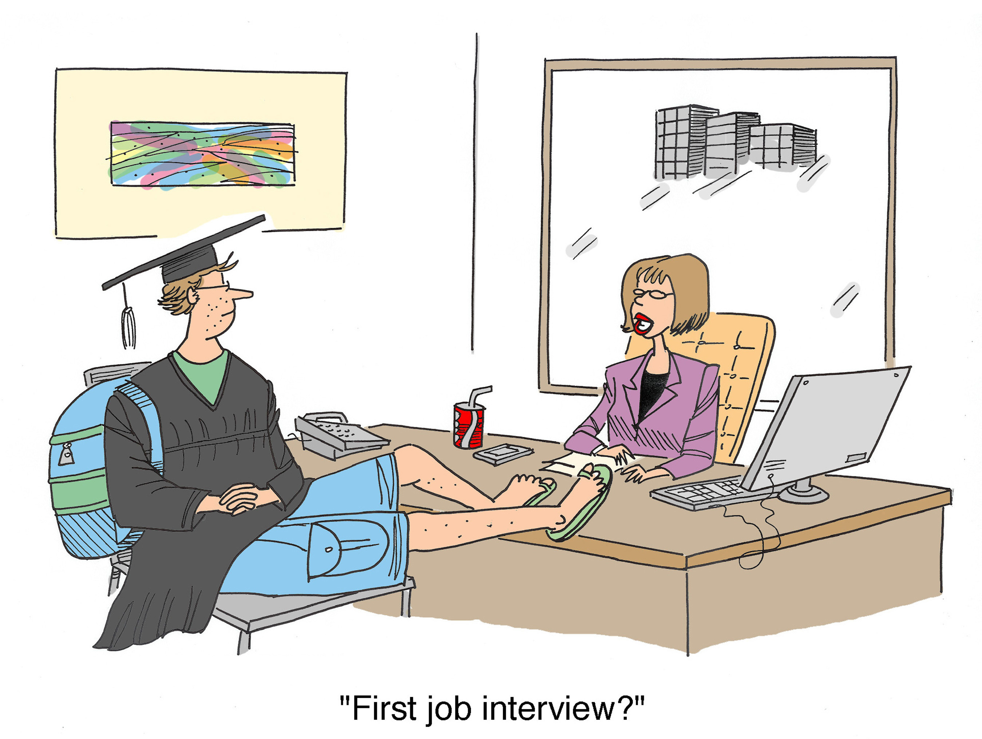 | TABE Testing by Appointment only | Orientation 9:00-11AM | Job Skills Match 2pm  Career Exploration 2:30pm  Resume Building 3pm | Interviewing with Confidence 2:00pm  What Employers Want 2:30pm  Job Applications  3:00pm
30 | 31 | 01 | 02 | 03
 | TABE Testing by Appointment only | Orientation 9:00-11AM
Helpful Websites:
https://www.arizonaatwork.com/
https://www.azjobconnection.gov/ada/r
For more information: 2001 College Drive Ste 94, Lake Havasu City (928-453-0710) TTY 711
Closed on all Federal Holidays. When the week is interrupted by a holiday. We will attempt to move the workshops to another day that week.

“An Equal opportunity Employer Auxiliary aids and Services Available upon request to individuals with Disabilities”

