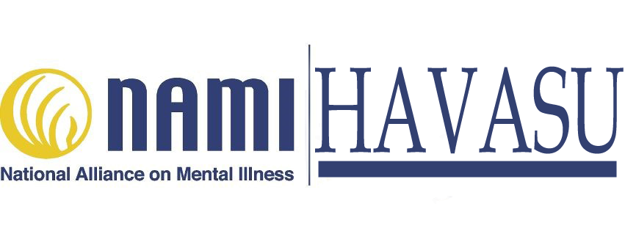

**NAMI HAVASU FAMILY SUPPORT GROUP**

***NAMI*** *envisions a world where all persons affected by mental illness experience resiliency, recovery and wellness.*

**You are not alone. Fight the stigma of mental illness through education and support.**

**NAMI Havasu Announces New Monthly Program**

**FAMILY SUPPORT GROUPS**

**Where:** **Havasu Community Health Foundation**, 94 Acoma Blvd. S., # 101

**When: One time per month – April 25 &** every 4th Wed. of ea. month)

**Time: 6 PM – 7:30 PM - Those who attend are family members and close friends of a person with mental illness**. **Participants must be** **age 18 or over. Call Keenan Norman, 760-662-4448, or email Chaplain Joy Smith at** [**songsofsoul@aol.com**](mailto:songsofsoul@aol.com)

***Coming in June:* “Connections,” a support group for people who have a mental illness. Call DJ Carpenter about this program, 928 208-5741.**

