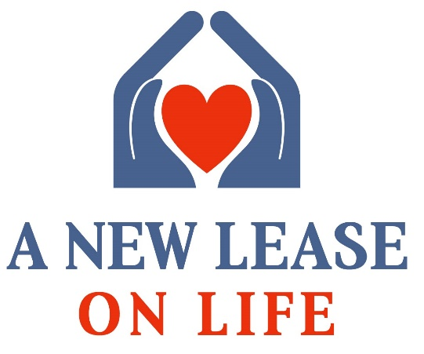

Christopher Todd, a Phoenix-headquartered developer of innovative single-family gated rental communities comprised of one- and two-bedroom single-story smart homes, has a 501(c) 3 nonprofit program called A New Lease on Life™. This giveback program is currently focused on providing three-year rent-assistance for eligible Veterans transitioning from the U.S. Armed Forces to civilian life, providing a home rent free, with specific terms, to a selected transitioning Veteran who has met the requirements, completed the application and essay requirements, been vetted by a community panel and ultimately selected after an in-person interview. The company may also elect to offer a helping hand up via some other means as new communities opens, evaluating the needs of each area in which the company develops.
Christopher Todd Communities has partnered with Vets’ Community Connections (VCC) to enhance their direct engagement with the overall Veteran and Military community in Maricopa County. Additionally, VCC will support the selection process and bring in additional community based and Veteran-based organizations from the neighboring areas of selected communities to make the final Veteran selection process decision.

Vets’ Community Connections (VCC) is a Maricopa County initiative connecting veterans, military and their families with local residents willing to share their expertise and knowledge about life in Maricopa County.

VCC empowers community members to do more than say, “thank you for your service” by filling a key need of local veterans, military, and their families: getting answers to a whole range of questions that fall outside the realm of traditional nonprofit and government support. The VCC’s partnership with Maricopa County’s 2-1-1 call center ensures veteran, military, and family callers have an easy way to get connected.

Program Details: Christopher Todd Communities (Veteran), A New Lease on Life ™

A Veteran* or a spouse of an eligible Veteran** will be granted rent assistance for a period of three (3) years during three (3) consecutive twelve-month leases. The program discount will be applied as follows:

During the first twelve-month lease, the resident will pay a sum equal to fifteen percent (15.0%) of the Premises Rent monthly as a deposit that will be used to offset the Premises Rent during the first renewal lease term. If the recipient chooses to relocate prior to the end of the agreement, the amount of the deposit that has not been used to offset rent during the first twelve-month renewal lease term will be donated to A New Lease on Life foundation. During the first successive twelve-month renewal lease term, the resident will pay thirty-five (35%) of the Premises Rent monthly. During the second successive renewal lease term the resident will pay 75% of the Premises Rent monthly.

Christopher Todd Communities will also waive the monthly fee for the Technology Package during the entire term of the lease. The Veteran will be responsible for utilities, Valet Waste removal, and other non-rent fees.

Minimum Eligibility Requirements:

- Only E-6 and below Ranked Military/Veterans may apply.

- *Must be an Honorable Discharged Veteran (or within 90-days of exit from service with a command letter, “Positive Statement of Service”) and has served during the Post 9-11 era with a direct connection to supporting one of the active war campaigns during service time.
OR
- **Must be an unmarried spouse of a Veteran that was KIA/MIA during combat or combat training during any Post 9-11 era American conflict.

Additional Program Requirements:
Veteran or Veteran spouse selected for A New Lease on Life must meet or agree to the following additional clauses
- Must reside in the Arizona at the time of application or can prove that Arizona is the service member/Veteran’s home of record (enlisted from AZ).
- Must occupy the rental unit as their sole primary residence.
- Must meet the income requirements/eligibility for household size and can show financial ability to make the required payments over all lease period(s).
- Must be able to provide financial information and agree to enter into a financial planning/savings counseling program (if required post assessment).
- Must be willing to be engaged with A New Lease on Life ™, Christopher Todd Communities, and Vets’ Community Connections and to fully participate in their resources and engage in monthly, quarterly, and yearly check-ups and media engagement opportunities. Missing any of these requirements will be considered non-compliant and are grounds for lease discount termination and you will be converted to the market-rent.
- Must be willing to share and highlight your stories, studies, and service efforts on all community partners and media websites (You will sign a media release waiver)
- There is no money back if lease is terminated early. The saved funds will be converted to closed out paid rent. Recipient will be billed for beyond wear and tear damages to the unit.
- The recipient must comply with all Mark-Taylor Residential lease requirements in addition to items noted in line 5 above, as well as the mandatory monthly rent deposit into the managed savings plan. Tenant has 10-days to bring the situation current. If not, an eviction, per the lease agreement, will commence. Please note that all of these communities are smoke-free, including the homes and all public/common spaces.
- Must have a minimum household income of $40,000.00 and/or can demonstrate financial stability for term of lease(s)
- Must be ready to ENGAGE with your new COMMUNITY because they can’t wait to WELCOME YOU!

Benefits/Access by Participating in A New Lease on Life™:

A New Lease on Life™ doesn’t stop at rent assistance. We make sure our Veterans transition with guidance and support from the overall community—especially the Veteran community.

- Access to the Veteran Community and leadership opportunities within the network.
- Access to Veteran Health/Wellness programs within the network.
- Access to attend professional development opportunities (conferences, workshops, and trainings).
- Invitations to special Veteran gathering events
- Access to Veteran affinity groups and talent acquisition networks at top companies across the U.S.
- Opportunities to meet and volunteer with Veteran supportive organizations including The Mission Continues and Team RWB.
- Access to Veteran Small Business/Entrepreneurship curriculum provided by SBA.gov, SCORE, and SBDC.

Applications Data Points:
In addition to completing this form, the applicant must also provide copies of their DD-214 or a valid proof of Honorable Service.

Full Name:
DOB: SEX: Married: YES or NO
Family Size:
List Names & Ages

Branch of Service Served: Dates Served:
Deployments (locations and dates of deployments):

Financial Requirements/Income Verification: (To be determined by Mark-Taylor Residential, the property management company retained by Christopher Todd Communities)

Items Mark-Taylor Residential may require: (DO NOT send in with your application)
Last year tax record(s)
Last year banking records
Provide all proof of outgoing bill pay
Factor in total family income metrics

Essay Requirement with Application:
In 1500 words or less, how will A New Lease on Life™ benefits you and your family? (Example: What can your family leverage or become with this type of assistance and how will you pay it forward?) Be explicit on how this program can help you have a larger impact on the community, your city, and Maricopa County.

Application Affirmation:
I, _____________________________ (Full Legal Name of Applicant) affirm that all information provided by me for this application process is true and I agree to all program details and requirements if I am selected for this opportunity, A New Lease on Life™, A New Way to Live by Christopher Todd Communities.

_________________________________________ _________________
Printed Full Legal Name Date

_________________________________________ _________________
Signature Date

Submission Details:
Submit all completed application data points and required documents via email only to:

Joanna@VCCPhoenix.org
Subj. Line: A New Lease on Life Application_Last_Name (Applicants Last Name)

Disclaimer:
Vets’ Community Connections will collect all applications and documents for this program and will coordinate the delivery of the qualified completed packages to the selection committee. DO NOT contact any affiliates during the review process. All inquiries can be submitted to Joanna@VCCPhoenix.org with the subj. line: Lease Application Inquiry.

Disclaimer:
All fees for this program will be collected and or managed by Christopher Todd Communities or Mark-Taylor Residential.

Other Veteran Assistance from Christopher Todd Communities
Christopher Todd Communities values and thanks all Veterans who have served our country. We know our freedom comes through your hard work and sacrifices. To say thank you, all Honorably-Discharged Veterans are eligible to receive the special Veterans Pricing on a one-year lease at all Christopher Todd Communities which includes:

- Administrative Fees Waived ($150-$200 Value)
- Application Fees Waived ($50 Value)
- First 4 weeks FREE! Or existing Concession ($1,150-$1,500 Value)
- Technology Package Fee Waived for 6 months ($900 Value)
Total Savings $2,250 - $2,650

Version August 1, 2018

