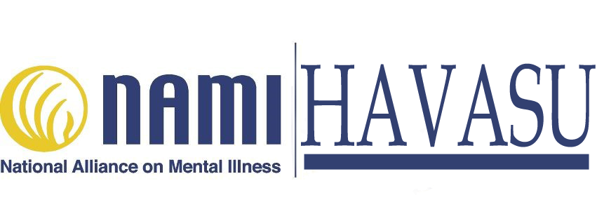

**NAMI *Havasu’s* Family Support Group *meets,***

***Every 4th Wednesday of each month, at* 6 PM – 7:30 PM. *Location: Havasu Community Health Foundation, 94 S. Acoma Blvd., Ste. 101.***

***Ste. # 101.***

NAMI Family Support Groups are free, confidential groups for families of individuals with mental health conditions. Through this group, members can find hope and support by connecting with

others who face similar challenges and gain support.

NAMI Havasu, an affiliation of the National Alliance on Mental Illness, now offers a NAMI Family Support Group which meets once each month. This is NAMI program is for people who have loved ones with mental illness. Age limit is 18 and up.

**Participant Perspectives**



“Before coming to the support group, we had never spoken about mental illness to neighbors, friends and often not even to our relatives.”

“NAMI Family Support Group really works and it makes the group experience even better.”

“I just attended my first NAMI Family Support Group and the facilitators and the group experience was just the kind of support I was seeking at this time.”

**Contact us to find out more about NAMI Havasu Family Support Groups!**

We need people in Havasu to help advance the cause of NAMI Havasu.

Call Betty Bradley453-7869for more information.

**About NAMI**

NAMI, the National Alliance on Mental Illness, is the nation’s largest grassroots mental health organization dedicated to building better lives for the millions of Americans affected by mental illness. NAMI Havasu is an affiliate of NAMI AZ. NAMI Havasu and dedicated volunteer members and leaders work tirelessly to raise awareness and provide essential education, advocacy and support group programs for people in our community living with mental illness and their loved ones.

**Betty Bradley**  **928-453-7869**

**Joyce Grabowski 651-280-9485**

**Keenan Norman 760-662-4448**