SAVE THE DATE
VETERANS RESOURCE FAIR
SATURDAY NOVEMBER 3, 2018
11:00AM-2:00PM

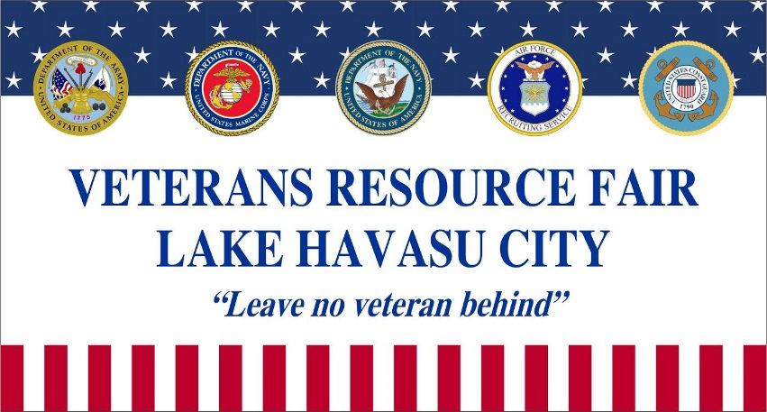

Veterans seeking assistance or information are invited to a
VETERANS RESOURCE FAIR
at the Columbian Hall
186 London Bridge Road, Lake Havasu City.
(formerly known as Knights of Columbus)

Many counselors from local Veterans Resource Organizations
will be present to help with:
legal assistance, housing, resume assistance,
employment opportunities, credit & finance counseling,
DAV/VA benefit applications, VA Health Care Assistance,
food sources, clothing, furniture and more.

The Veterans Thrift Store will have a “Clothing Closet”.
DLA military surplus and other clothing will be immediately
available for anyone in need.

The Marine Corps League Color Guard will present colors at 11 am.

A complimentary lunch and refreshments will be served.

Looking forward to seeing you there!

