Elks Veterans Appreciation Dinner
Thursday - February 20, 2020
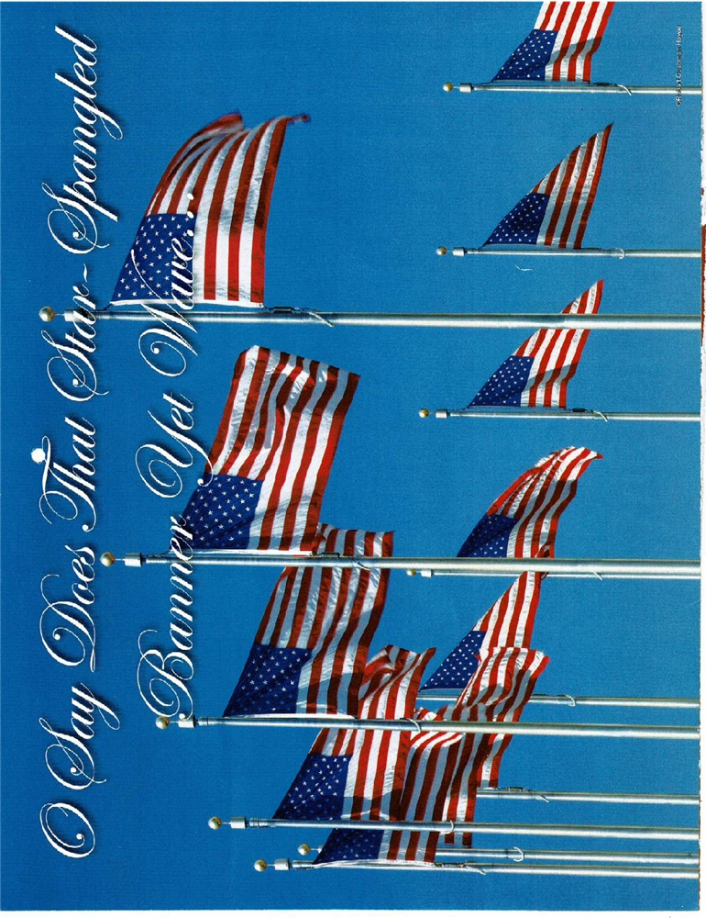
Start at 5:00 PM and ends at 7:00 PM

Richard Joseph, Elks Veterans Chair: The VETERANS COMMITTEE is offering free
Spaghetti dinners to all veterans and their spouses on Thursday, Feb. 20, 2020, to show our appreciation for their service. Some veterans reside at the Gardens apartments and may need transportation to the Elks. For all others who come to support our veterans, the cost is only $6.00 per person. Please support this. You can call in your reservation, too.

The dinner is from 5:00 PM to 7:00 PM only. Those lodge members and outside guests who are not veterans (open to the public) pay at the door $6.00 per person. Those who furnish a ride to and from the lodge for a veteran will get one complimentary dinner. There will be a sign-up sheet on the Bulletin Board in the Social Quarters for members and guests to reserve dinners.
Elks Editor, Sarah for Richard Joseph, Elks Veterans Committee Chair.

